1. Vietnam’s Railway: From Legacy to Velocity
Transport spending hit 7% of GDP in 2025 (~USD 36B)
Rail and metro are now national priorities.

2. Macro snapshot
Vietnam’s railway system, long constrained by aging infrastructure and limited coverage, is now central to the country’s 2030 goals. The government lifted infrastructure spending to 7% of GDP in 2025 (≈USD 36B), nearly 40% higher than last year. Transport (rail + metro) is one of the top two priorities alongside electricity.
- Network today: ~3,000 km, <5% electrified
- Policy push: Resolution No. 188/2025/QH15 gives Hanoi & HCMC fast‑track powers for metro expansion
- 2030 vision: 25+ new lines, integration with ports and highways, positioning rail as a backbone for green mobility
Source: The Investor, Trade.gov, B-Company

2. Spotlight Project: VinSpeed’s Bến Thành–Cần Giờ High-Speed Link

Recently approved, VinSpeed’s VND 102.43 trillion (≈USD 3.9B) project is Vietnam’s first fully private‑led high‑speed corridor.
- Specs: 54 km, 1,435 mm standard gauge, 350 km/h, fully electrified
- Timeline: Land clearance starts Q4 2025, operations by 2028
- PPP model: 85% debt-financed, 15% equity, 70-year concession
- Impact: Cuts travel time to ~20.3 mins, unlocks tourism in sea-reclaimed Cần Giờ
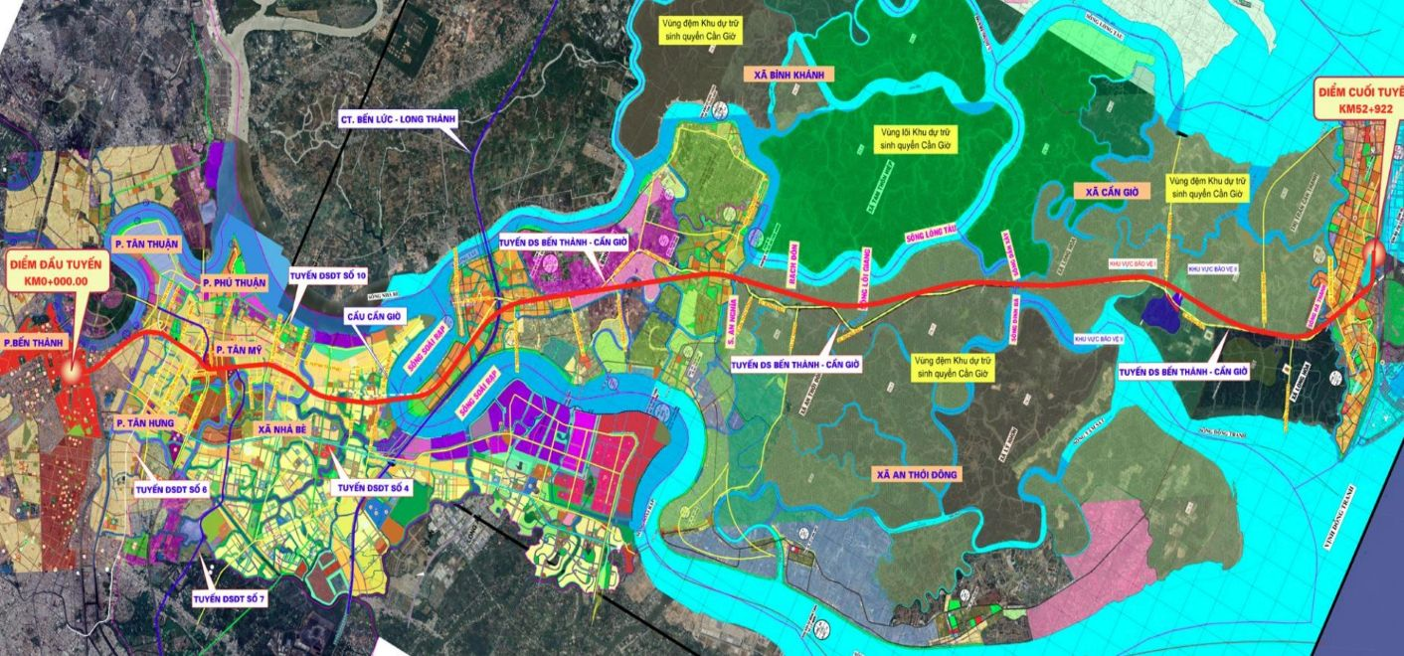
Source: The Saigon Times, Vinspeed, Vietnam Plus

3. Sector Growth: From Legacy to Velocity
Year | Passenger (million) | Freight (million tons) | Freight (million tonne‑km)
2019 | 2.85* | — | 3,742
2020 | 1.77* | — | 3,759
2021 | 1.147 | — | 3,600*
2022 | 4.52* | — | 3,650*
2023 | 6.10 | 4.50 | —
2024 | 7.00 | 5.00 | —
2025 (proj.) | 7.50* | 5.10* | 3,730*
Note: tons = cargo volume; tonne-km = cargo volume × distance traveled; * = back calculations
- Demand re‑rated: Passengers jumped from ~1.15m (2021) to ~7.0m (2024) — clear, sustained demand for better rail services.

- Freight is selective: Tonne‑km stayed ~3.6–3.8b while tonnage rose to ~5.0m (2024) — growth is in specific cargo routes (intermodal, LNG).
- Event‑driven trade: Near‑term wins are project‑linked (VinSpeed, metro contracts, VNR upgrades); avoid broad exposure until megaproject financing is nailed down
Source: B-Company, Vietnam Net, VN Express, National Statistics Office of Vietnam

4. Who is doing what?

Project | Lead | Status | Timeline | Why it matters
VinSpeed Bến Thành–Cần Giờ | Private (VinSpeed) | Shovel‑ready | Land Q4 2025 → Ops 2028 | Proof of private HSR delivery
North–South HSR | State | Approved in principle | Phased; multi‑decade | Transformational if financed
HCMC metro expansion | HCMC / Govt | Fast‑track | 2025–2030 (phased) | Last‑mile + integration
VNR freight upgrades | Vietnam Railways | Ongoing | 2024–2026 (rollout) | Intermodal, terminals, wagons
Port‑rail links | Ports / VNR | Planning / early works | 2025–2030 | Unlock container flows

Source: Vietnam News, The Diplomat, Vietnam Investment Review, Tuoi Tre

5. Takeaway
- Bottom line: Rail moved from recovery to investable momentum -> private pilots (VinSpeed) + metro fast‑tracks create near‑term catalysts.
- Where to focus: Contractors, rolling‑stock suppliers, intermodal terminals, and digital freight platforms tied to confirmed projects.
- Main risks: Financing, land clearance, and execution delays. Treat exposure as event‑driven, not index‑wide.
CTA: Watch VinSpeed land clearance (Q4 2025) and metro tender awards for the next buy signals.

